To create the new directory we need to use the cmd Mkdir <directory name>. I created the directory name called my_folder_linux_T1

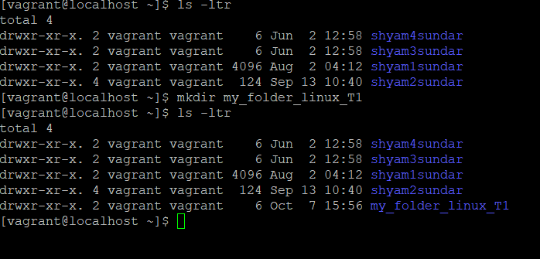

*To create the new file we need to use cmd called touch <file name> .I created the file name called my_file

* to create the some text in to the file to create the text we need to use the cmd called echo create the text > file name . so I create the texet like echo "hello team am shyam" >>my_file

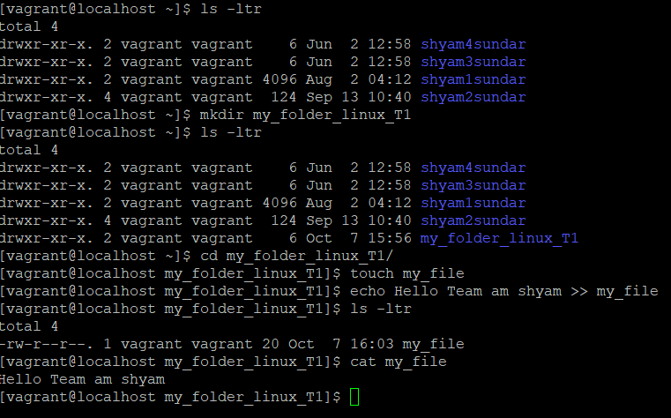

*to create the another file same touch cmd I used and creacted the with some txt with using the echo cmd

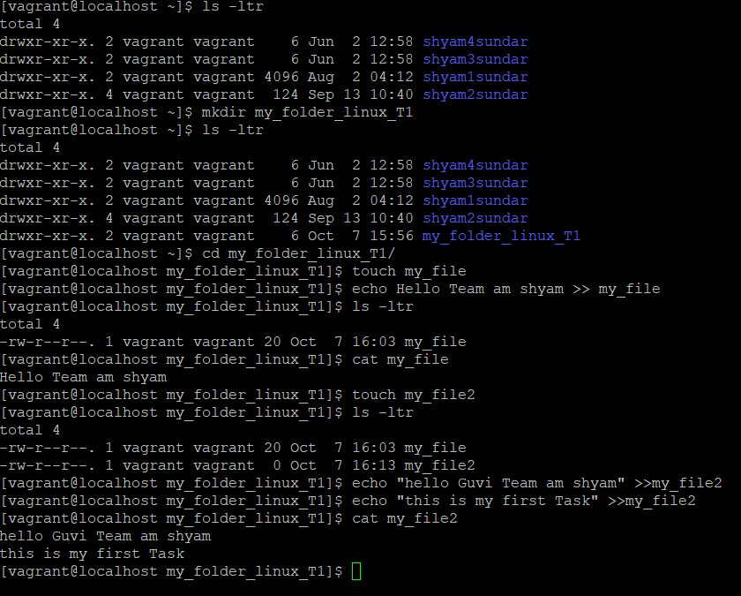

Ans: I used the cmd to creaste the mult file touch {1..20}file name and for rename i used the cmd called mv file name

